Notre Dame 2020 MSBA Program

SQL DATABASE CREATION GUIDE

Booz Allen Hamilton

Table of Contents

**Disclaimer and Overview** 2

**Database and Tables Creation** 3-5

**Sample Queries** 6

# **SQL**

**Disclaimer:** This guide begins under the assumption that BAH has already established a server connection where this new database will be created, and the user has been given the correct login credentials. If not, please contact your team’s database administrator.

**Overview:**

**Step 1: Creating a new database environment within the designated server**

**Step 2: Selecting the correct database  
Step 3: Creating the tables in the database  
Step 4: Queries to check**

**Step 1: Creating a new database environment within the designated server**

1. 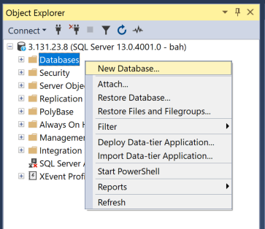Once connected to the server, in the object explorer to the left of the screen, right click the “Databases” option and select “New Database”

1. 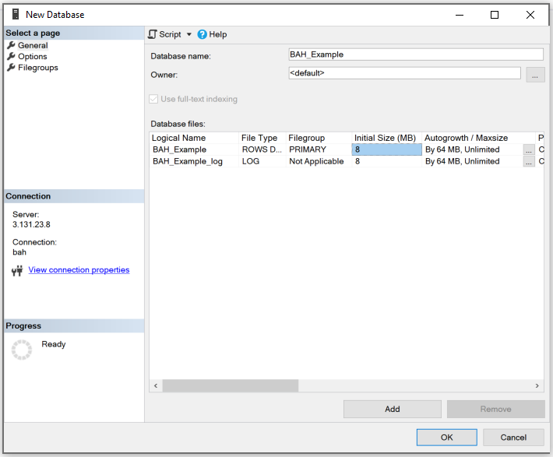Once the new database options appear, feel free to name the database. In this example, the name of the database will be “BAH_Example”. Be sure to name the new database something that is clearly aligned with its purpose. Best practice is to avoid special characters and spaces in the name.
2. In this example, we have left all other options set to the default, feel free to change if needed. Click OK to create the new database.

**Step 2: Selecting the correct database**

1. Now that the new database has been created, we need to ensure that the proceeding queries will run against that specific database. There are two ways to do this:
   1. In a new query, type “USE <yourdatabase>;”.
      1. In this example, the query will read “USE BAH_Example;”. Highlight the query and click the EXECUTE button, or F5.
   2. The other way that does not involve code is to select the database dropdown menu at the top left of your screen and simply select the database that is desired.

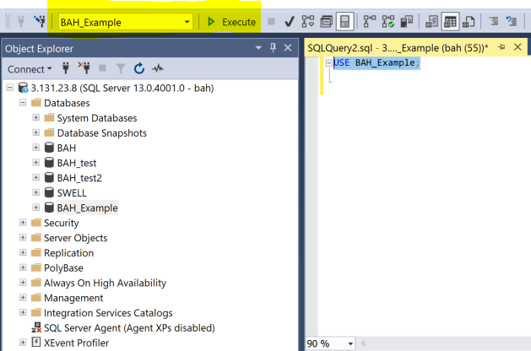

**Step 3: Creating the tables in the database**

1. Copy the entirety of the text document “SQL Generation Code” and paste into the query window being used.
   1. Each table begins with “CREATE TABLE” and ends with a semi-colon.
2. Be sure that the database name being used matches in the CREATE TABLE statement. See image below:
   1. This step must be done for each of the 7 tables

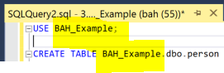

1. Highlight each table creation code one at a time and click the “Execute” button or F5.
   1. Be sure to highlight the entirety of each table from CREATE TABLE to the ending semi-colon or an error will appear.
2. Once all 7 tables have been created, right click the database name in the Object Explorer and click refresh. Check to see all 7 tables are now present when the “tables” option is expanded.

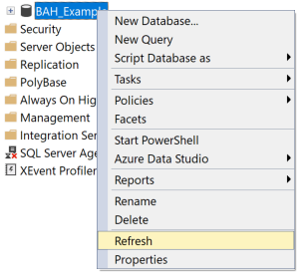 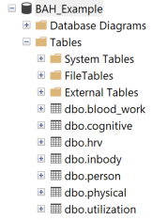

**Step 4: Queries to check**

1. Useful queries to check the database functionality:
   1. To check all data within one table
      1. “SELECT * FROM [schema].<tablename>
      2. Example SELECT FROM dbo.physical;
   2. To check data for a participant across 2 tables using INNER JOIN
      1. For most accurate participant matching across tables, join on pax_id

Ex.   
SELECT inbody.person_paxid, inbody.inbody_bodyfat, blood_work.blood_hdl

FROM inbody

INNER JOIN blood_work

ON inbody.person_paxid = blood_work.person_paxid